# Experiment 3: Neighbor Table Determination

**Aim:** To create neighbor table for a given network topology

**Objective:** After carrying out this experiment, students will be able to:

* Generate neighbor table for all the nodes in a given topology.
* Analyze how this is useful in the process of routing data

**Problem statement:** You are required to write a program that calculates neighbor table for all the nodes in a given network. Consider a network with 10 nodes that is deployed in an area of 500 m2. Your program should initially determine the distance between each node and all other nodes. Then the range of the nodes is given as input to the user. Using this range information, determine the neighbors of all the nodes.

**Analysis:** While analyzing your program, you are required to address the following points:

* How this is useful in the process of routing data?
* For a 3D topology, how would your program need to be changed?

**MARKS DISTRIBUTION**

|  |  |  |
| --- | --- | --- |
| **Component** | **Maximum Marks** | **Marks Obtained** |
| Preparation of Document | 7 |  |
| Results | 7 |  |
| Viva | 6 |  |
| **Total** | **20** |  |

**Submitted by:** K Srikanth

**Register No:** 17ETCS002124

1. **Algorithm/Flowchart**

***1. Start***

*2. Define a structure named ROUTER with following features: x and y coordinates*

*3. Declare an array of node ROUTER:R[node]numbered from 0to9*

*4. For i=0 to node-1 do*

*a. Input x and y coordinates of ROUTER-i*

*b. End for*

*5. Declare node × node 2d array with name d of type float*

*6. For i=0 to node-1 do*

*a. For j=0 to node-1 do*

*(Distance between two ROUTERs I and j)*

$$d\left[i\right]\left[j\right]=\sqrt{(r\left(i\right).x-r\left(j\right){.x)}^{2}+(r\left(i\right).y-r\left(j\right){.y)}^{2}}$$

*b. End for*

*c. End for*

*7. Input the router number:i*

*8. Input the range within which, Found ROUTERs have to be displayed*

*9. For j=0 to node-1 do*

*a. If d[i][j] ≤ range and d[i][j] > 0*

*i. Print i: ROUTER-number*

*ii.End if*

*iii.End for*

***10. Stop***

1. **Program**

**Code**

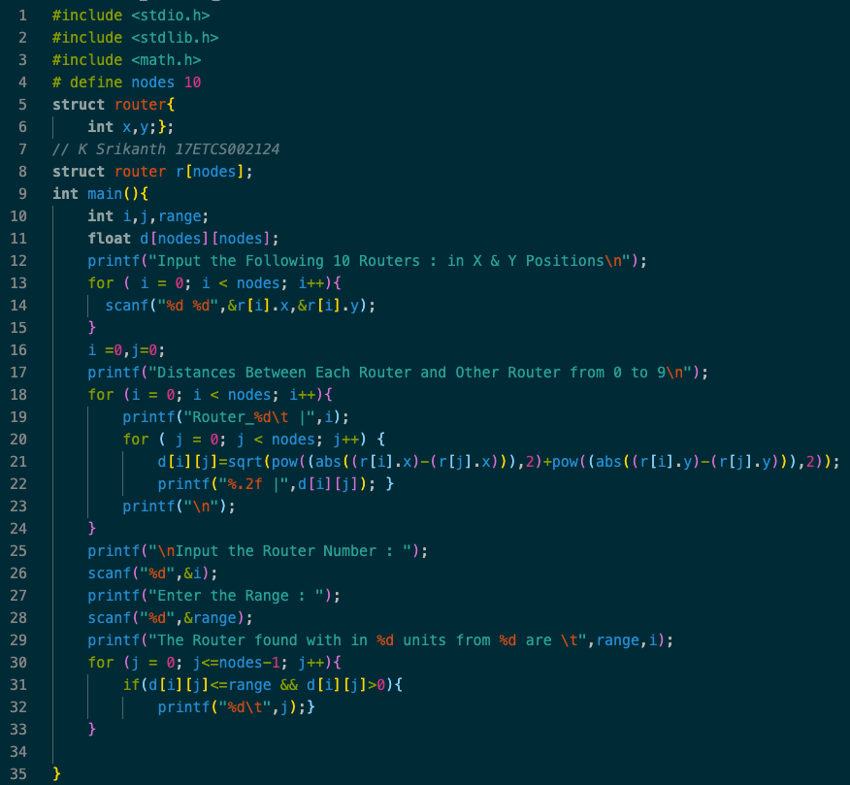

Figure 1 C Program for the given problem statement

1. **Results**

**To Run C Code**

*>> gcc filename.c*

**To Execute**

*>> ./a.out*

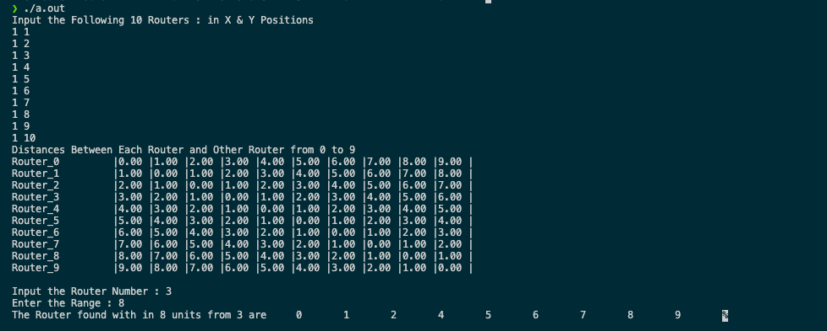

Figure 2 Output for C code (Figure 1)

1. **Analysis and Discussions**

* **How this is useful in the process of routing data**

The above process helps the ROUTER to find out nearest neighboring ROUTER in the

subnet and transmit packets of data.

* **For a 3D topology, how would your program need to be changed?**

In 3d topology, the ROUTER position is defined by 3 coordinates: x, y and z We can use

the similar formulae to obtain the distance between any two ROUTERs i and j with x, y

and z coordinates.

(Distance between Routers i and j)

$$d\left[i\right]\left[j\right]=\sqrt{(r\left(i\right).x-r\left(j\right){.x)}^{2}+(r\left(i\right).y-r\left(j\right){.y)}^{2}+(r\left(i\right).y-r\left(j\right){.y)}^{2}}$$

1. **Conclusions**

The main purpose of a router is to connect multiple networks and forward packets destined

either for its own networks or other networks. When a router receives a packet, it

determines the best path which involves the evaluation of multiple paths to the same

destination network through the neighboring routers and selecting the optimum or shortest

path to reach that network. The above program helps the router to find out nearest

neighboring router in the destined path.

1. **Comments**
   1. **Limitations of the experiment**

The algorithm is simple greedy approach to find out neighbors within certain range, the algorithm needs to select the router that can reach the destination network with minimum overall costs.

* 1. **Limitations of the results obtained**

The result obtained is just the closest routers from the given router, from a

neighboring table**.**

* 1. **Learning**

Routing techniques, network topologies and neighboring table determination.